**Project 3 - Thread App Reviews Dataset**

Team Members: Ankit Verma, Cesar Zea, Miloh E. George, Aina Teng

**Dataset:** <https://www.kaggle.com/datasets/jayagopal20/threads-app-reviews-dataset?select=threads_reviews.csv>

**Data and Delivery - Ankit/Aina**

**Deadline: Sept 27**

* Data components used in the project are clearly documented. (5 points) - Ankit/Aina
* The dataset contains at least 100 unique records. (5 points) - Ankit/Aina
* A database is used to house the data (SQL, MongoDB, SQLite, etc.). (5 points) - Ankit/Aina
* The project is powered by a Python Flask API and includes HTML/CSS, JavaScript, and the chosen database. (10 points) - Ankit/Aina

**Back End - Cesar**

**Deadline: Sept 25**

* Create html

**Java Script / Visualizations** (dropdown, zoom, filter)

**Start working: Sept 27**

**Deadline:**

* 1) Android vs iPhone - Cesar
* 2) Comments - Ankit
* 3) Number of comments - Elena

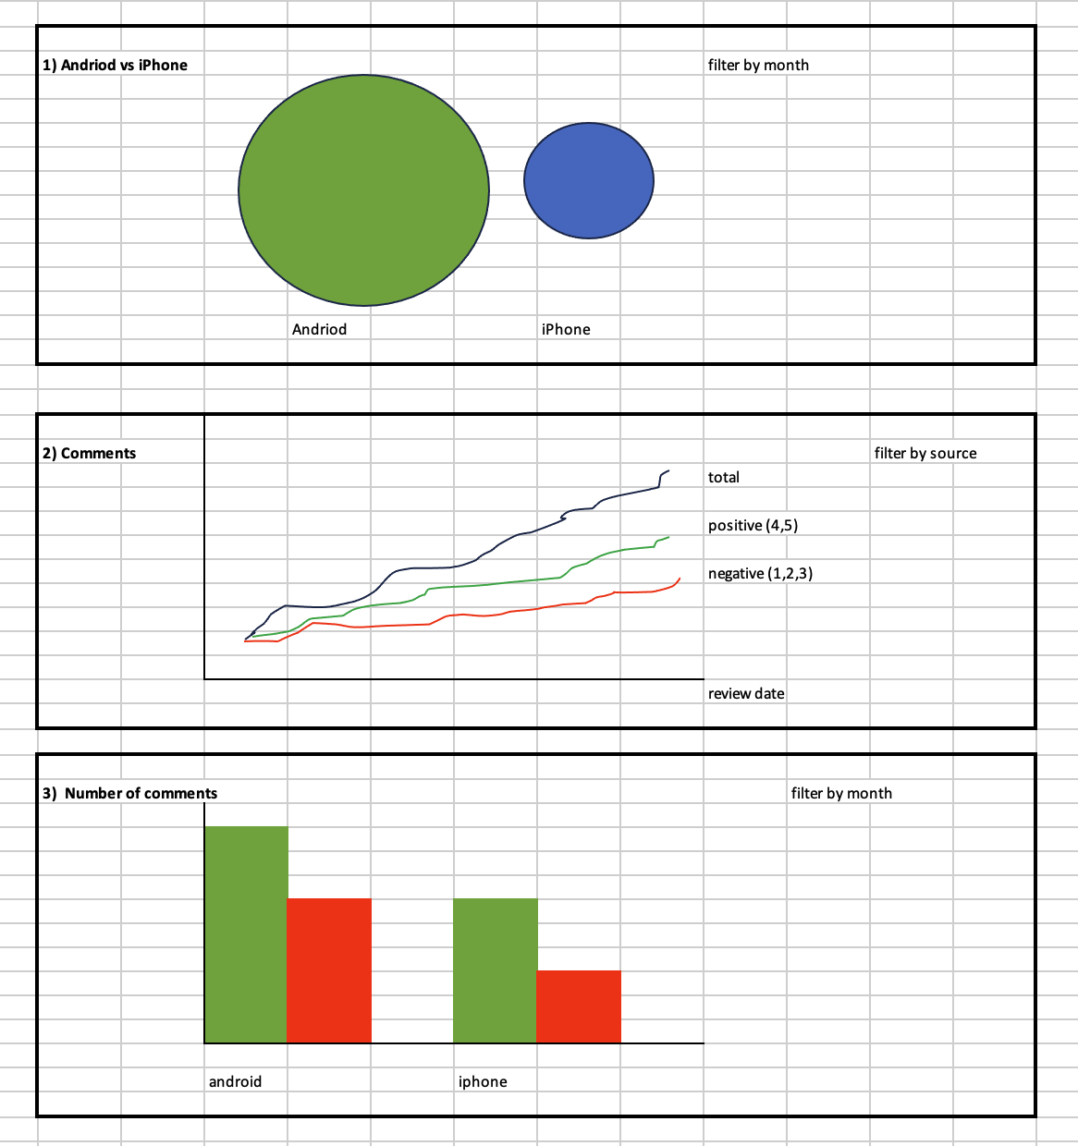

**Presentation Slides - Elena**

**Deadline:**

**Presentation Rehearsal**

**Deadline: Oct 2**

**Github - Elena**